**D3 – Data Visualization**

# **Exercise – D3**

**Student Name: Pulkit Agrawal Student Id: PXA180017**

**Date: 11-14-2018**

**Question:**

1. **Open your HTML page in WEB browser and take a screen shot of your page showing page Title (your name) and page background**

**Answer**

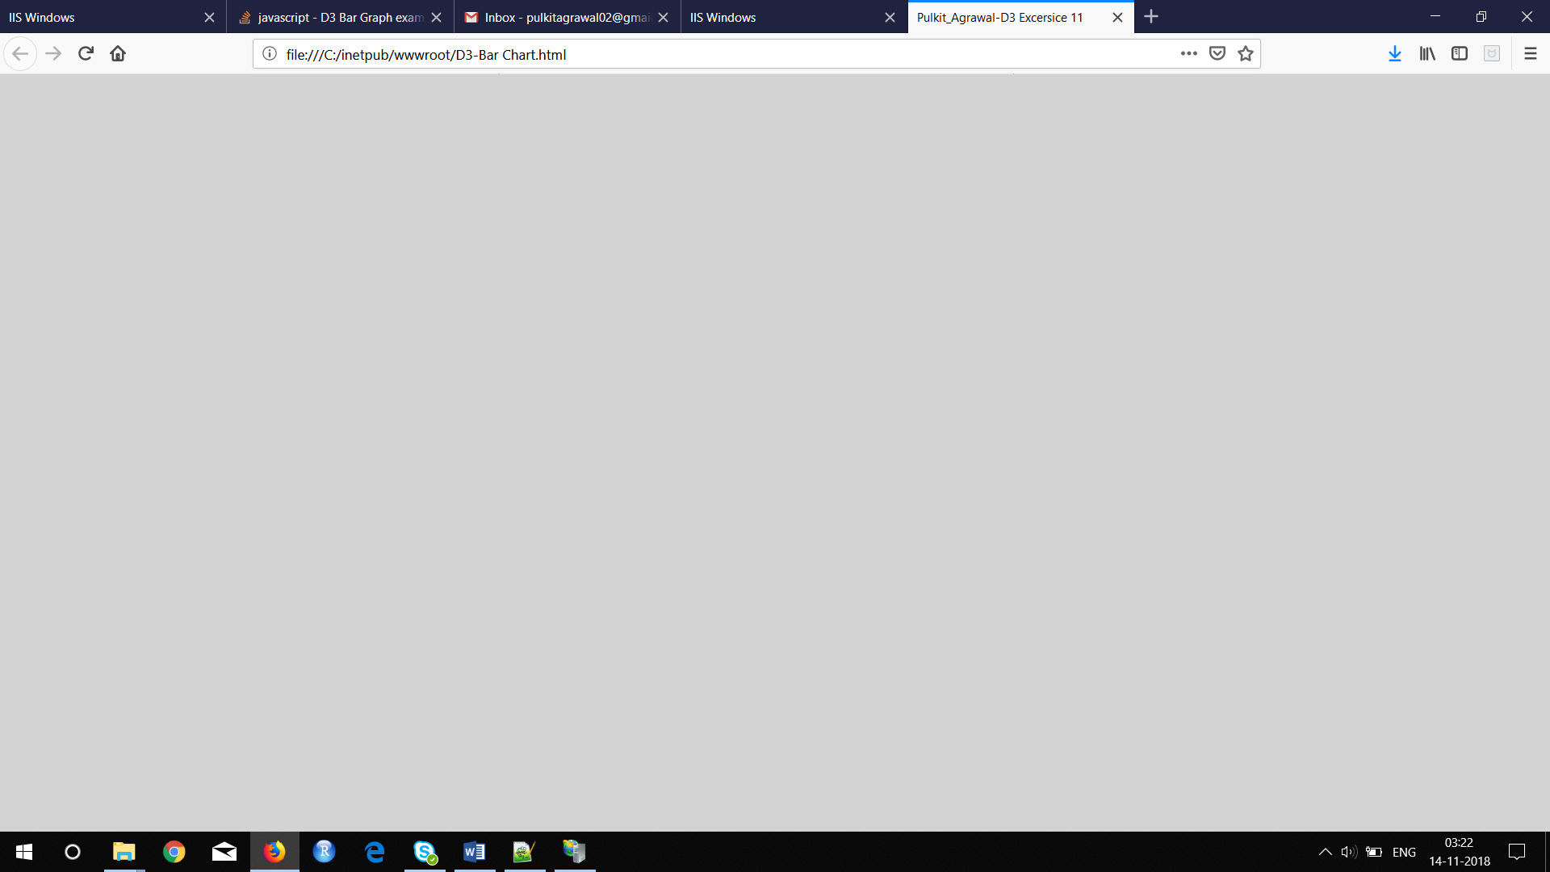

**----------------------------------------------------------------------------------------------------**

**Question:**

1. **Provide the screenshot of your html page displaying your name in the browser tab:**

**Answer** 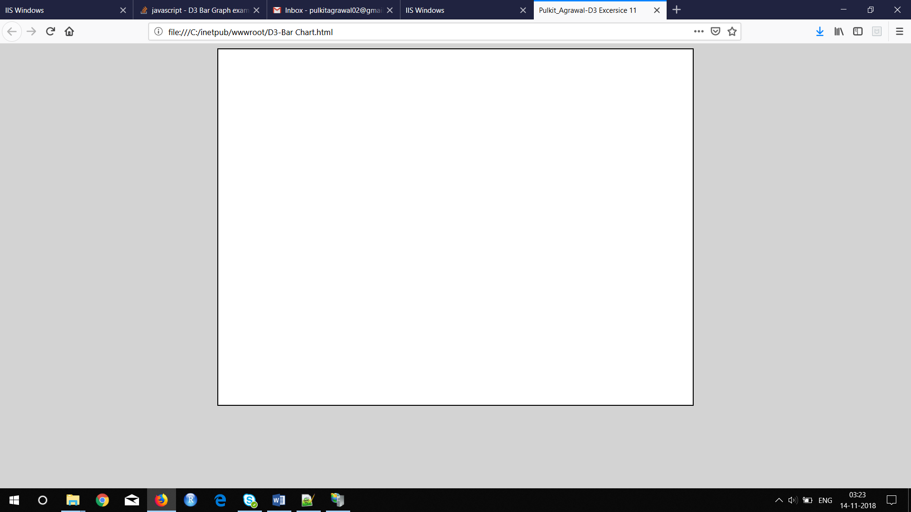

**----------------------------------------------------------------------------------------------------**

**Question:**

1. **Place the screen shot of your console showing data (objects)**

**Tip:** Clear console using button marked with red circle and refresh the page

**Answer**

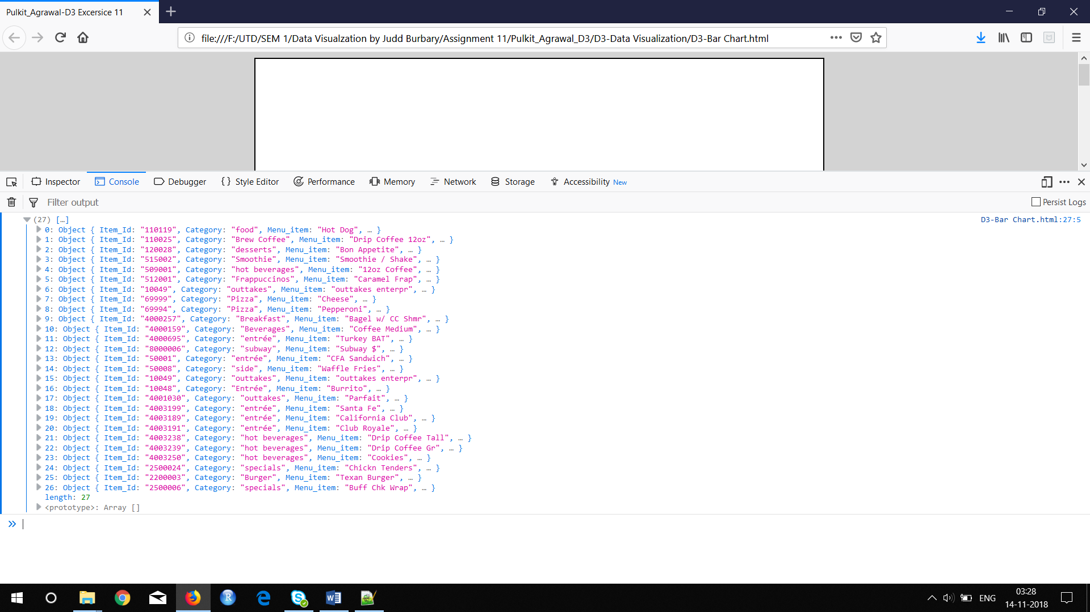

**----------------------------------------------------------------------------------------------------**

**Question:**

1. **Refresh your web page and paste a screenshot**

**Answer**

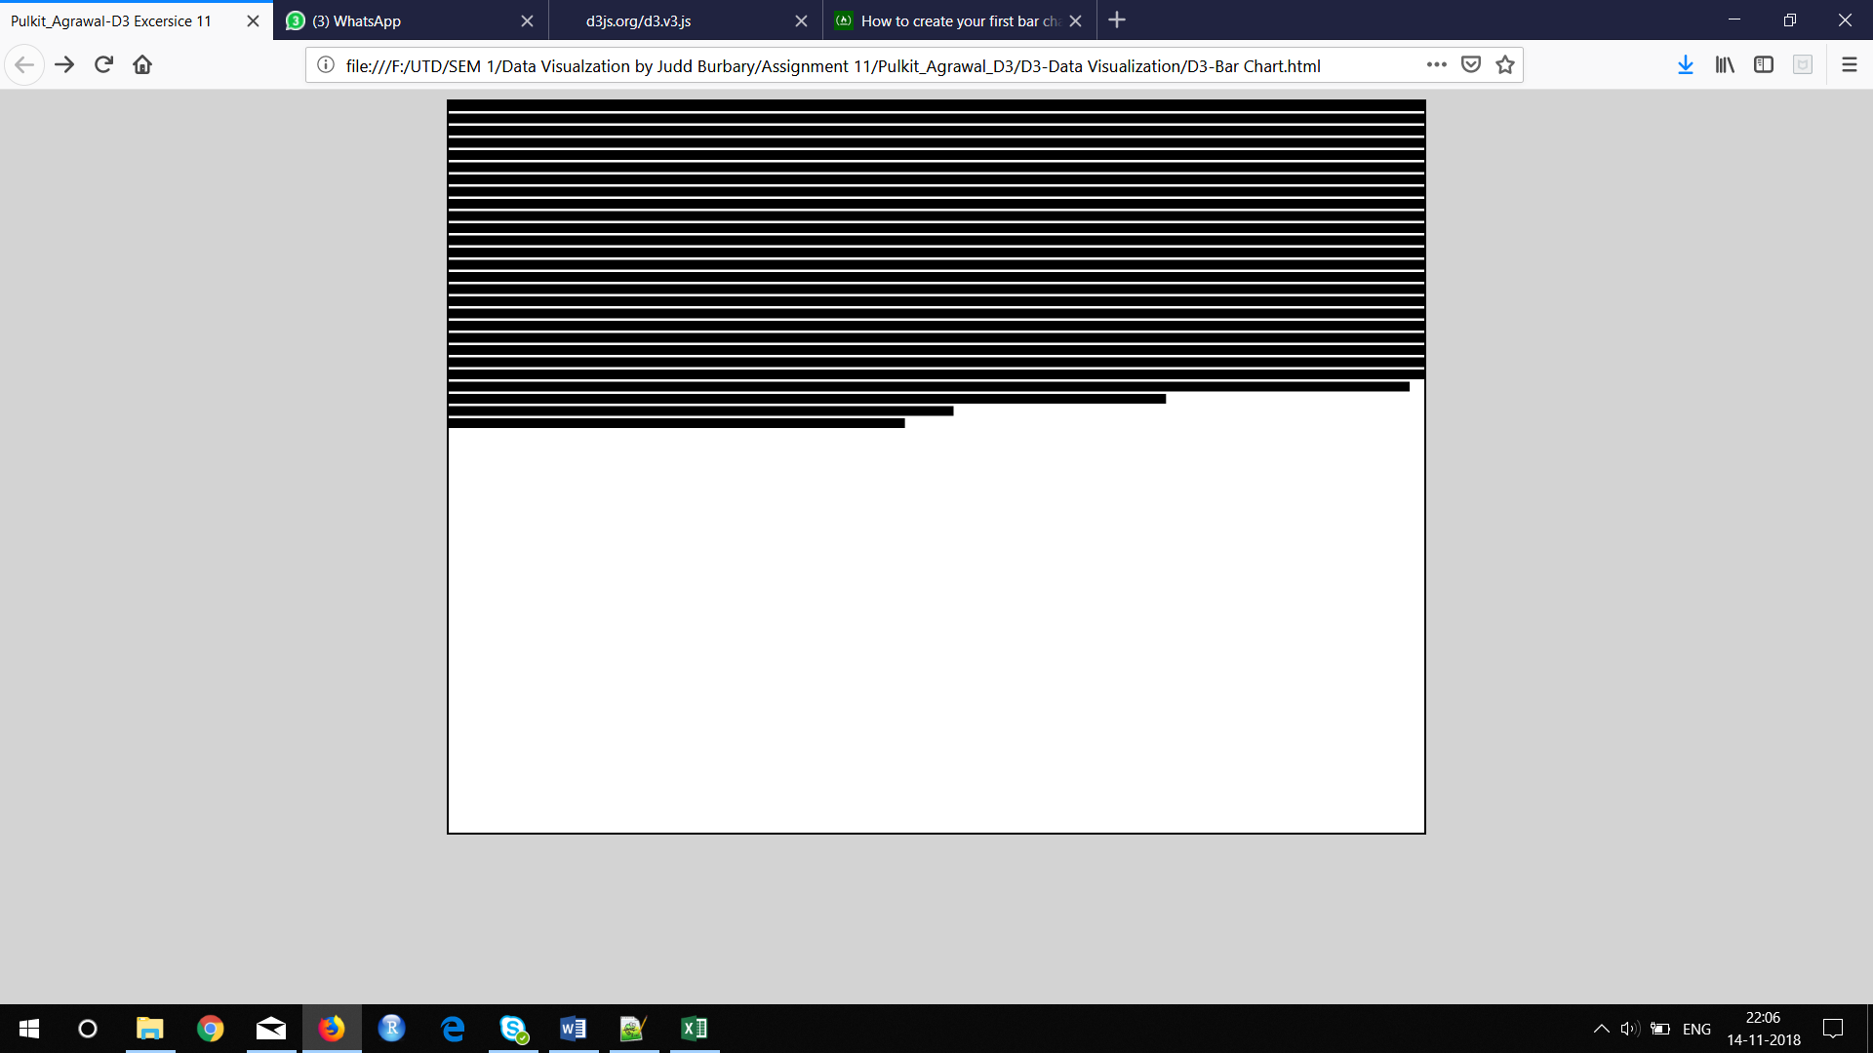

**----------------------------------------------------------------------------------------------------**

**Question:**

1. **Provide the screenshot of your html page displaying your name in the browser tab:**

**Answer**

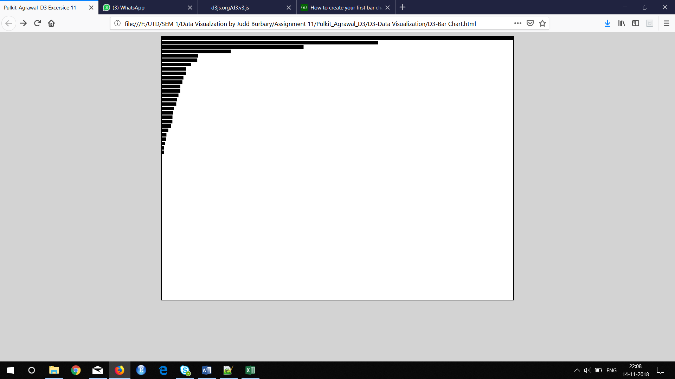

**----------------------------------------------------------------------------------------------------**

**Question:**

1. **Provide the screenshot of your html page displaying your name in the browser tab:**

**Answer**

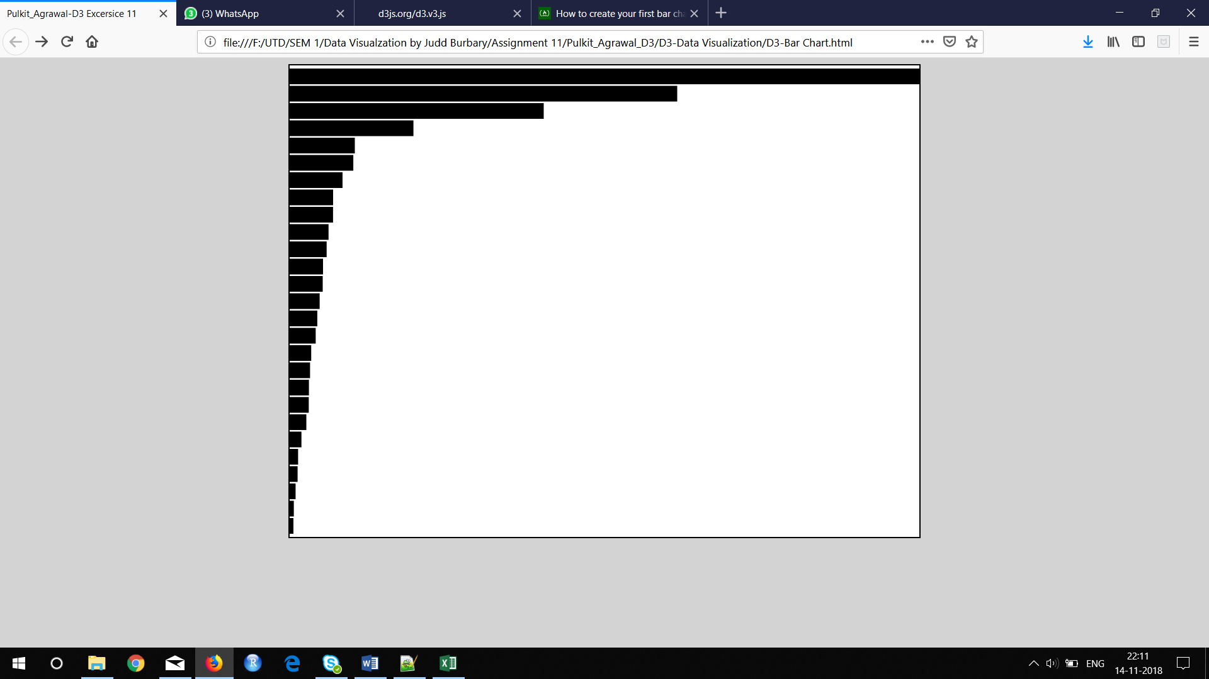

**Question:**

1. **Provide the screenshot of your html page displaying your name in the browser tab:**

**Answer**

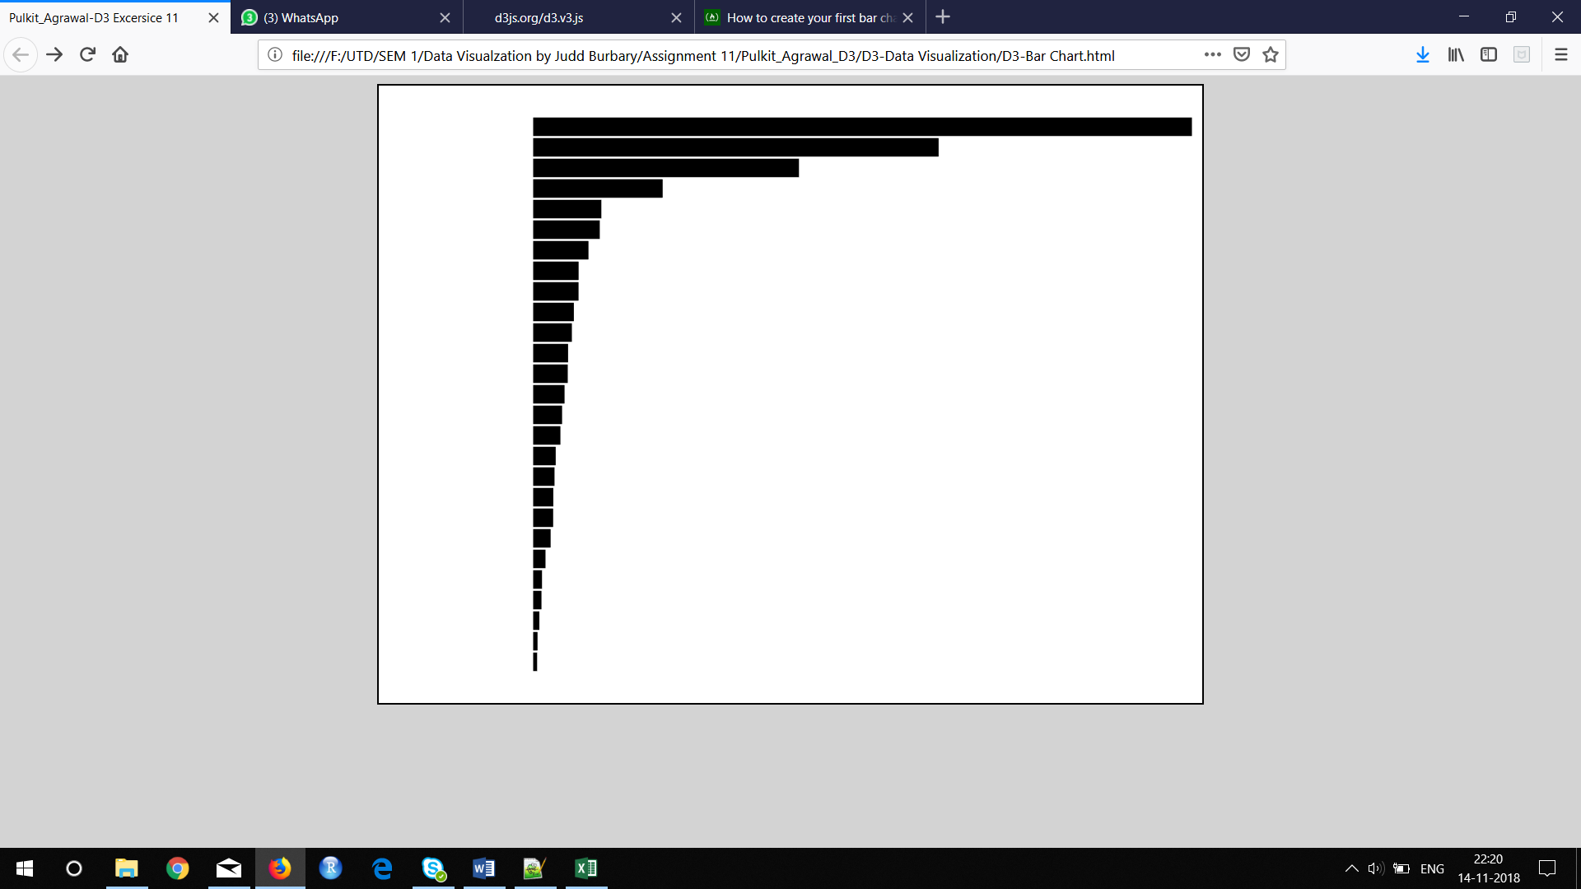

---------------------------------------------------------------------------------------------------

**Question:**

1. **Provide the screenshot of your html page displaying your name in the browser tab:**

**Answer**

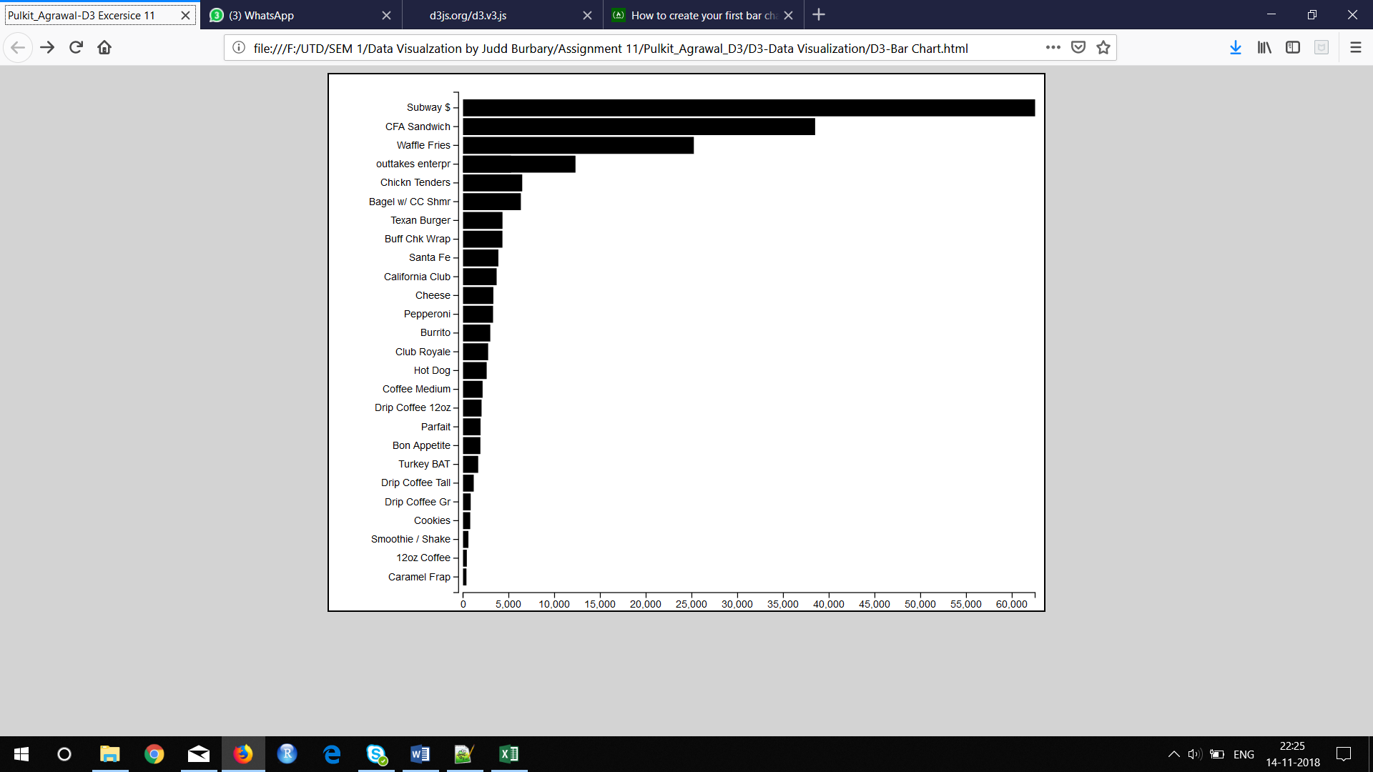

----------------------------------------------------------------------------------------------------------------

**Question:**

1. **Provide the screenshot of your html page displaying your name in the browser tab:**

**Answer**

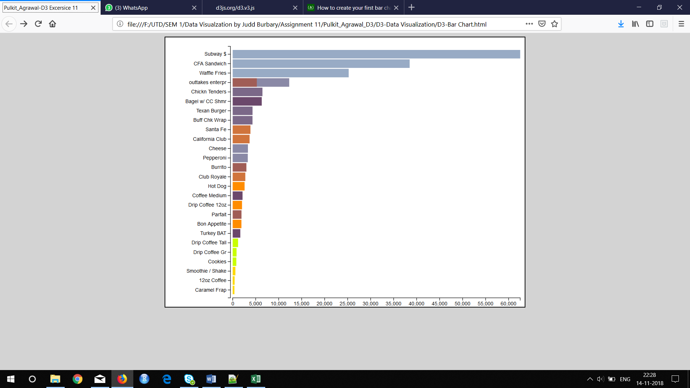

---------------------------------------------------------------------------------------------------

**Question:**

1. **Provide the screenshot of your html page displaying your name in the browser tab:**

**Answer**

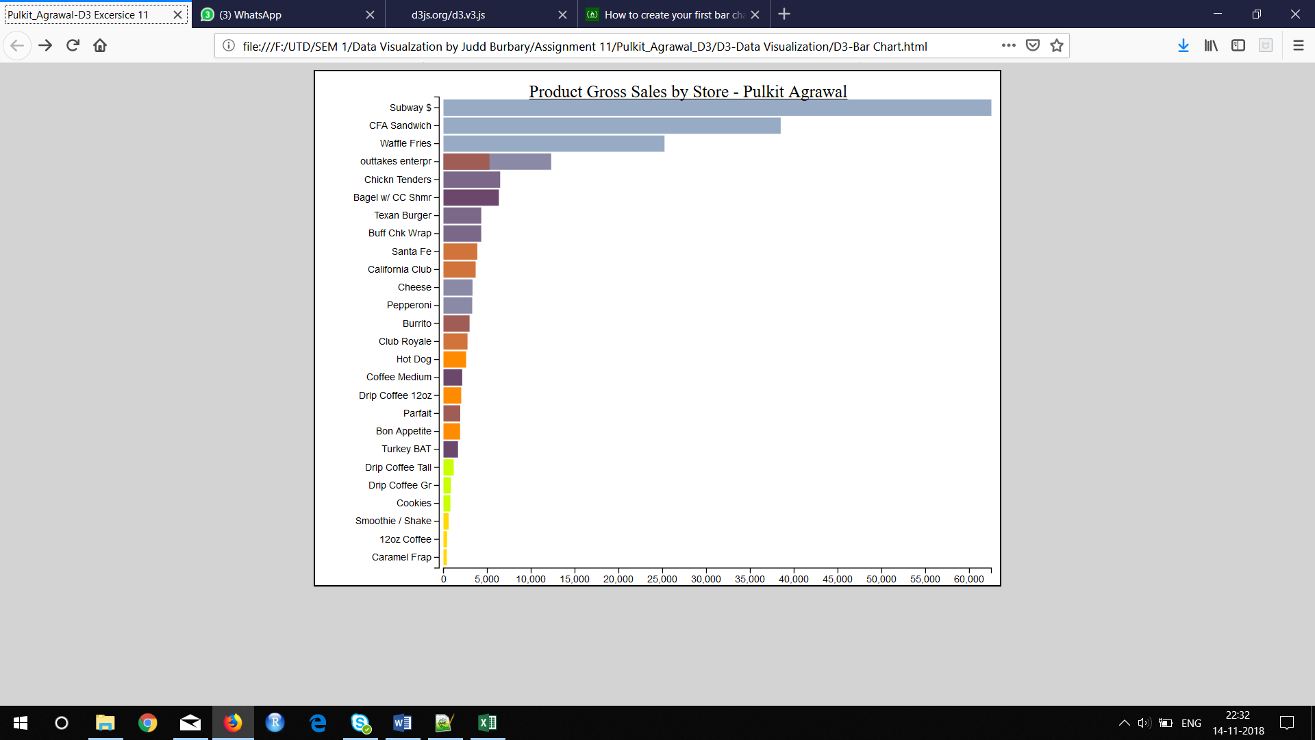

---------------------------------------------------------------------------------------------------------------------

**Question:**

1. **Provide the screenshot of your html page displaying your name in the browser tab:**

**Answer**



